西安市建设一带一路企业协会入会申请表
（样表）

申请单位名称 |  | 西安山林国际贸易有限责任公司
 |  | EVERGREEN INTERNATIONAL TRADING LTD. XI`AN
单位地址  （邮编） |  | 西安市国际港务区秦汉大道88号陆港保税大厦1610室
 |  | Rm1610, Inland Port Bonded Building, Xi’an International Trade & Logistics Park, China
单位座机 |  | 0086 29 83623998 |  |  | 单位邮箱 |  | shanlinguoji@163.com |  | 单位网址 |  | www.xiansl.com
法定代表人 |  |  |  | 名姓 | 郝树周 |  |  | 联系人 | 名姓 | 段素霞
 |  |  |  | 职务 | 董事长 |  |  |  | 职务 | 秘书
 |  |  |  | 手机 | 0086 13345678922 |  |  |  | 手机 | 0086 15202431501
 |  |  |  | 邮箱 | haoshuzhou@163.com |  |  |  | 邮箱 | dsx@xianbr.cn
 |  |  |  | 微信 | haoshuzhouQQ.com |  |  |  | 微信 | 15202431501
单位简介  （中文） |  | 公司坐落于西安国际港务区内的综合保税区, 是经国家工商、商务部门批准成立的具有一般贸易和边境小额贸易进出口经营权、主营俄罗斯中亚粮油产品的专业公司，是港务区首个“走出去”企业，主要致力于与中亚各国和俄罗斯的粮油贸易。  公司2014年从俄罗斯进口油菜籽4万吨，2015年又获得4万吨从俄罗斯进口油菜籽的《中华人民共和国进境动植物检疫许可证》，成为我国首批试验性进口俄油菜籽的主要企业。  近两年来在俄罗斯合资建设有油脂加工厂等项目，实现了多年来我国从俄进口菜籽油的零突破，为大批进口油菜籽打下了基础，开辟了新的国际市场。  公司总投资4.85亿元人民币，在西安国际港务区综合保税区内开发建设西安国际港务区丝绸之路进出口商品展示交易中心，是“西安港务区重点项目”和“西安市丝绸之路经济带重点建设项目”，将成为丝绸之路经济带沿线国家保税商品专业展示交易平台。
单位简介  （英文） |  | The company is located in the Xi'an International Port area within the comprehensive bonded area, is approved by the national industrial and commercial sector, the establishment of the general trade and border trade and import trade rights, the main Russian Central Asian grain and oil products, professional companies, A "going out" business, mainly committed to the Central Asian countries and Russia's grain and oil trade.  The company in 2014 from Russia imported rapeseed 40,000 tons in 2015 and access to 40,000 tons from Russia imported rapeseed "People's Republic of China Entry and Exit Animal and Plant Quarantine Permit", becoming China's first batch of experimental imports of Russian rapeseed enterprise.  The past two years in Russia joint venture construction of oil processing plants and other projects, to achieve over the years China's Russian imports of rapeseed oil from the zero breakthrough for a large number of imported rapeseed laid the foundation, opened up a new international market.  The total investment of the company is RMB485 million yuan. The development and construction of the Silk Road Import and Export Commodity Exhibition and Trading Center in Xi'an International Port Area is a key project of "Xi'an Port Area" and "Xi'an Silk Road Economic Zone" in Xi'an International Port Area Comprehensive Bonded Zone Construction project ", will become the Silk Road economic belt along the national bonded goods professional display trading platform.
单位宣传  照片  （电子版可选择插入） |  |  |  |  |  | 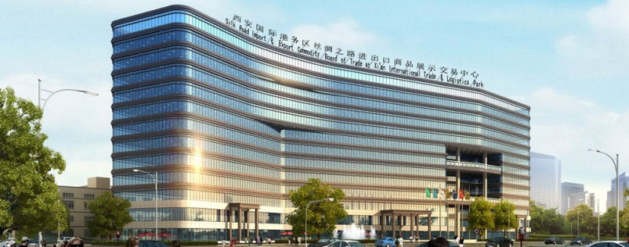
申请 |  | 我单位接受协会章程，按时缴纳会费，希望成为协会会员，特此申请。  （盖章）  2017年 8 月 8 日  （纸质版须盖章）
（以上为申请单位填写）
秘书处意见 |  |  | 秘书长签字：  年 月 日
理事会意见 |  |  | 会长签字：  年 月 日
协会信息 |  |  | Add:1610,Lugang BondedBuilding, International Trade Logistics Park, Xi'an, China(Code:710026)  Tel: +862983623998 E-mail:shanlinguoji@163.com Skype:shanlinguoji@hotmail.com  地址：中国西安国际港务区综合保税大厦16层1610室(Code:710026)

